Exercise : Gas Turbine
A gas turbine is a thermodynamic machine whose role is to produce mechanical energy from thermal energy. In most applications, the gas turbine is coupled with an alternator to produce electricity.

Part 1
From a thermodynamic point of view, there are several types of gas turbine. The objective of this part is to model the most classical type based on the Brayton cycle (figure below). In particular, the working fluid (gas) undergoes three successive transformations: compression, combustion and expansion. In this exercise, we will consider a gas turbine where the high and low pressures are 1 and 15 bar. The development of the model should be done step by step.
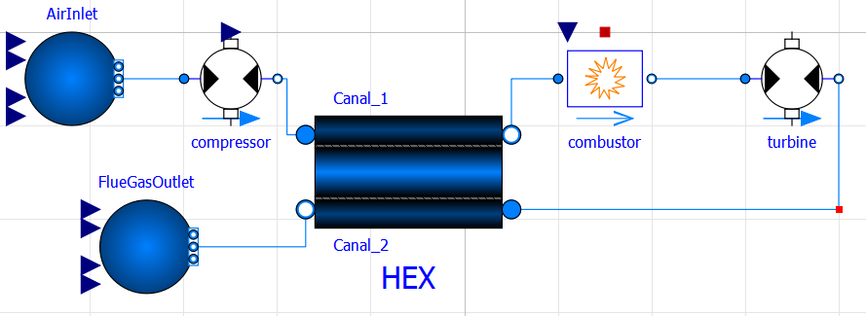

Step 1
In this step, we aim to model the compression phase. Develop the model below using the following classes:
- from caldis.components import FluidBoundary
- from caldis.components import Compressor
The working fluid is supposed to be the ambient air:
be_air = CoolPropBackend("Air")
at 1 bar and 20 °C.
The compressor has a mass flowrate of 1 kg/s.
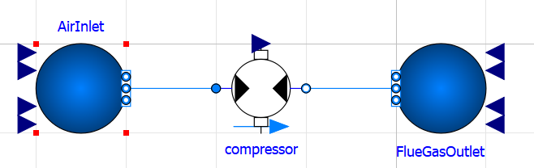
Question 1. First, it is assumed that the isentropic efficiency of the compressor is equal to 1. What are the compressor outlet temperature and the compressor power? The actual efficiency is 0.86. What are the temperature and the power? Comment on the results.
In what follows, the isentropic efficiency of the compressor keeps 0.86.

Step 2
Create another system, named gt_step2_combustor, where we add a combustion chamber using the following class:
from caldis.components import CombustionChamber
Due to a technical constraint, the flue gas temperature at the combustor outlet does not exceed the limit temperature of 1400 K. We suppose that the relative pressure loss in the combustor chamber is 4%, the fuel used is methane with a lower heating value LHV of 50e6 J/kg. The fuel has a temperature of 25 °C and pressure of 15 bar.

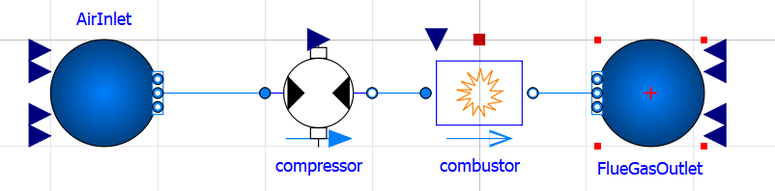
Question 2. What is the fuel mass flowrate?

Step 3
We complet the cycle by adding a turbine whose class is:
from caldis.components import Turbine
The turbine has an isentropic efficiency of 0.89.
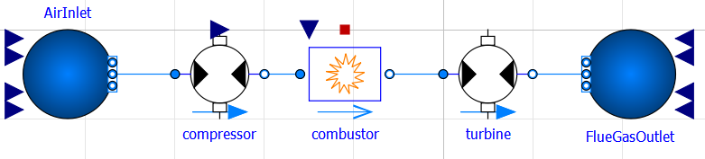

Question 3. What are the mechanical power generated by the turbine and the power consumed by the compressor?

Question 4. What is the efficiency of the cycle? What is the efficiency of the ideal Brayton cycle working at the same conditions? Explain the difference.

Part 2

Question 5. What is the flue gas temperature at the turbine outlet?

Most of the available energy is lost in the flue gas at very high temperatures. To improve the performance of the system, a possible solution is to recover the fatal heat and to reinject it into the system. We therefore aim to model the cycle below. Create another system and use the following class of heat exchanger:
from caldis.components import SizingHX
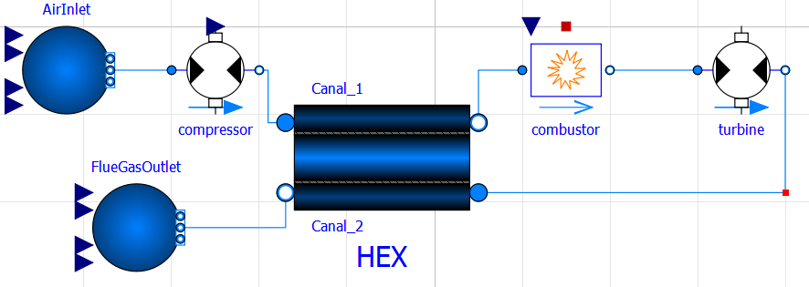
The effectiveness of the heat exchanger is 0.7 and remember that we need to respect the temperature constraint (limited to 1400 K)

Question 6. What is the efficiency of the system with recuperation? What is the pinch value of the heat exchanger?

The efficiency of the system depends on the amount of recovered heat, and therefore the size of the heat exchanger. Study the evolution of the efficiency when the heat exchanger size increases.

Question 7. Comment on the evolution of the efficiency. Compare its maximum value with the theoretical efficiency at the same working conditions.

Answers

Question 1
Isentropic compression T = 354 °C, P = 343 kW,
Real compression T = 407 °C, P = 399 kW,

Question 2
Flowrate = 0.0167 kg/s

Question 3
P_turbine = 719 kW

Question 4
efficiency of the real cycle : 37 %

Question 5
T = 516 °C

Question 6
Efficiency 40.9 %, pinch = 30K

Question 7
…

Contact : Cong Toan TRAN, MINES Paris, PSL University

